Steps for conducting Windows system

a. Mount the disc image with Arsenal image mounter. This will help u to review and get access to
the data in the disc.

There are many hidden files in the windows file system (starts with $) that are not visible. One
way of viewing those files is through cmd command – dir /a.
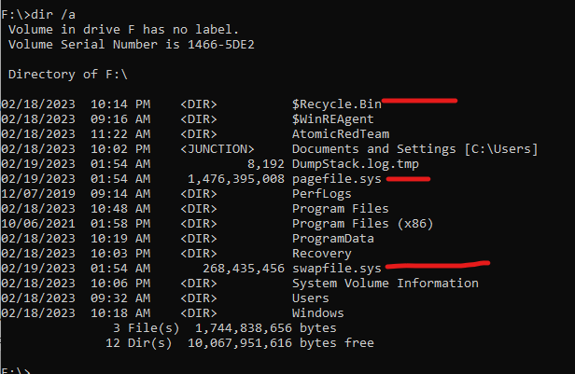
A more detailed view can be seen through FTK Imager. In the SS below we can see files starting
with the character “$”. We have MFT, BOOT.

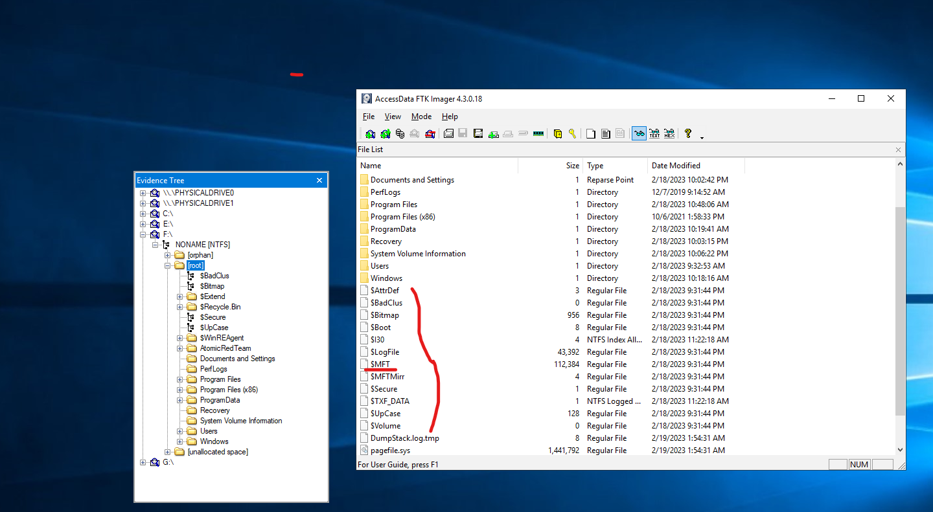

b. Extract relevant artifacts and keep them in a consolidated place. For this, we can use
KAPE/gkape.

Kape enables us to extract individual artefacts and also has compound packages which extract set
of artefacts. One such example is “Kape triage package” which will be used for this use case.

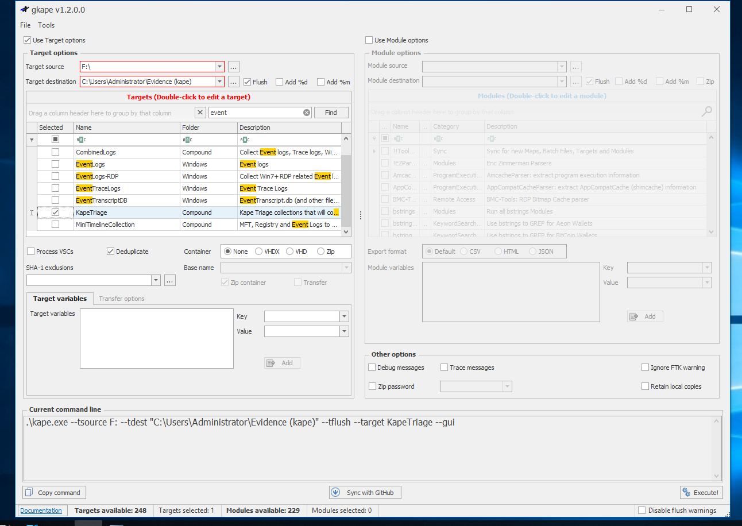
Kape has configuration files which specify location of files to be extracted. Like for e.g. event
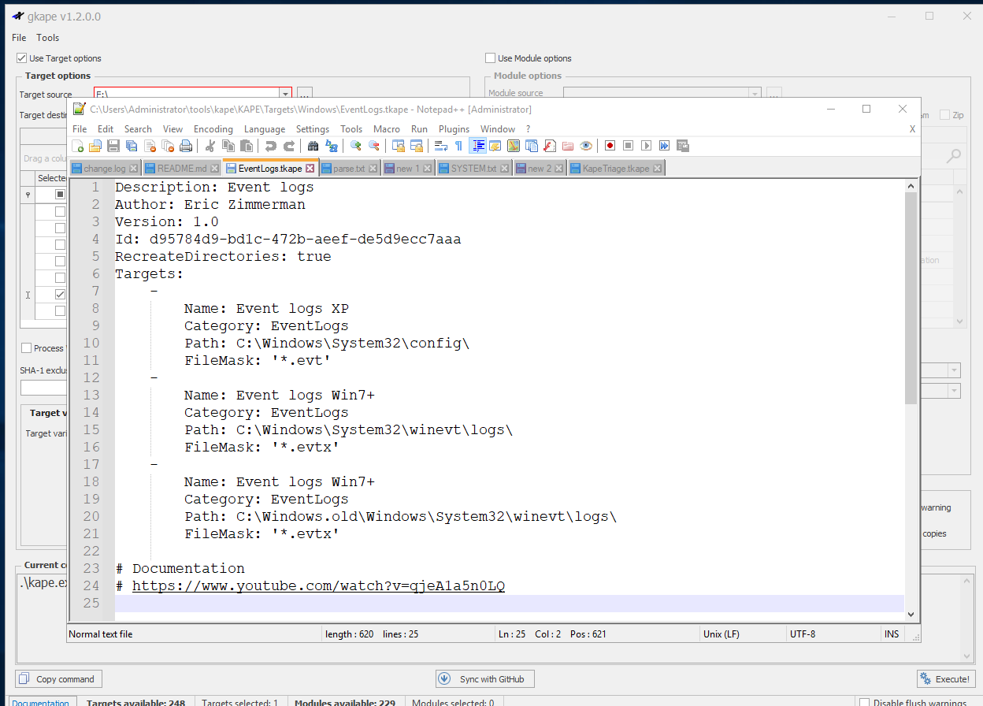
log consists of the following:-
So, extracting relevant artefacts concludes the first steps in conducting forensic business.
Let’s dive down to the analysis part now.

Sources of evidences:-

a. Memory
b. Disk – NTFS, Windows registry, Windows Event logs, Other windows artifacts

Disk Analysis process:-

a. System and user information – Registry
b. File Analysis – NTFS
c. Evidence of execution – Background Activity Monitor, Shimcache, Amcache, Prefetch
d. Persistence Mechanism – Run keys, Startup folder, Scheduled Tasks, Services
e. Event log analysis

Analysing system and user information with Windows registry

The registry hive is present under
<users>\Windows\System32\config -these are system sepcific registry hives.

The windows registry entries HKEY_CURRENT_USER is symoblic link which is used to store
settings and configuration, information on user (HKEY_USERS).

If we look at structure of HKEY_USERS we can see the registry key
HKEY_CURRENT_USER is pointing towards it.
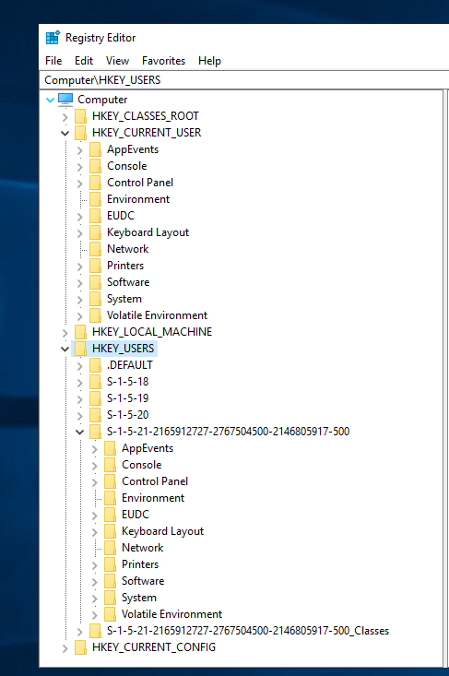

In SS we can see
HKEY_CURRENT_USER is an exact
representation of the user with
“HKEY_USERS\S-1-5-21-2165912727-
2767504500-2146805917-500”.

HKEY_USERS\S-1-5-21-2165912727-
2767504500-2146805917-500_Classes is
created by windows for users who have
logged in interactively i.e. interacted with
GUI using mouse, keyboard etc.

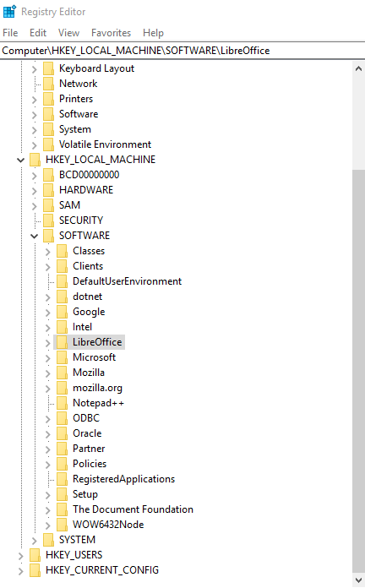
HKEY_LOCAL_MACHINE stores information
about settings of the local machine. (system specific
key).
In SS, we can SOFTWARE key which contains
preferences of various software's installed on the
system.

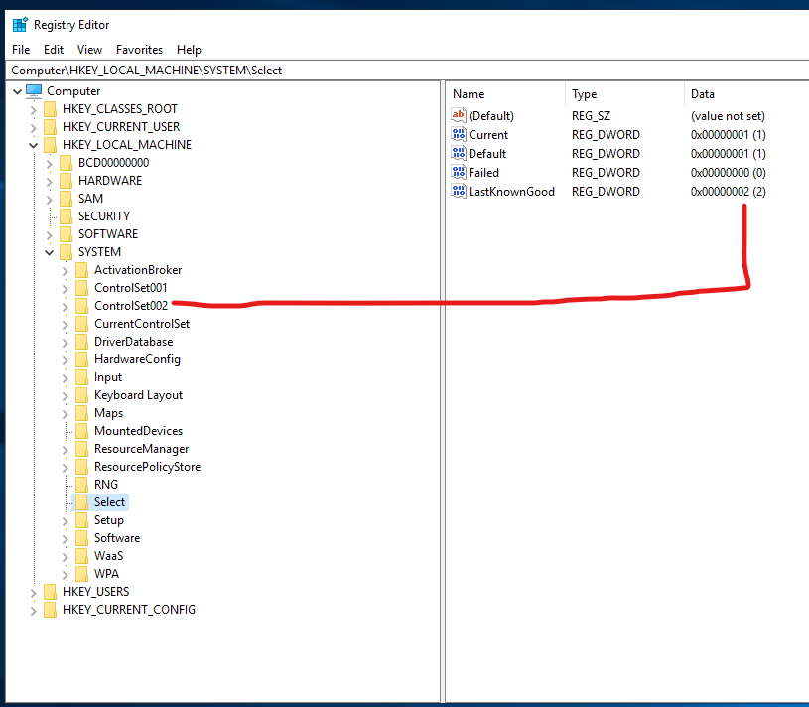

HKEY_LOCAL_MACHINE\
SYSTEM contains control sets
which windows uses to pick up
configurations.
We can see there are 2 control sets and
from the
HKEY_LOCAL_MACHINE\
SYSTEM\Select key we can
determine the last known used control
set as highlighted.

The HKEY_CLASSES_ROOT stores extension mapping. It tells which extension should be opened by a particular app. Contains user and system preferences.

NTUSer.dat is the file that is mapped to HKEY_CURRENT_USER. (\Users\adrish).

UsrClass.dat is the file mapped to HKEY_USERS under the particular SID and also contributes to HKEY_CLASSES_ROOT about the file extension choices and also contains data of HKEY_USERS\S-1-5-21-2165912727-2767504500-2146805917-500_Classes.

Registry exploration with RegRipper and Registry explorer

First we will go with registry explorer. Drag and drop registry hives directly in Registry explorer.
First we will drop system specific hives stored in “user/windows/system32/config”.
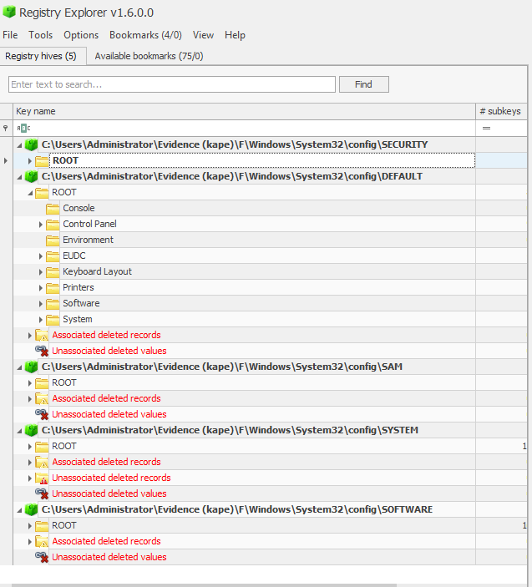
One of the benefits of registry explorer is that it
bookmarks important hive components.

Registry exploration and information extraction with Reg-ripper

Reg-ripper gives text based outputs and has pearl plug-ins which can be used to extract specific information.
Reg-ripper command line utility:-
Sample query
rip.exe -r C:\Users\Administrator\Evidence_(kape)\Analysis\Registry_analysis\system\SOFTWARE -p winver

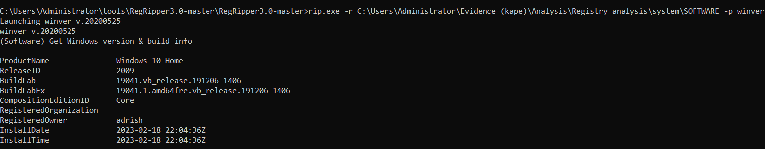
-r – specify registry hive to query
-p – Plug-in for extracting specific information in this case windows version

Parsing registry hives in bulk with reg-ripper
For parsing registry hives in bulk we can use the following dos snippet.

“for /r %i in (*) do (rip -r %i -a > %i.txt)” – All the registry hives should be one folder.

User accounts analysis using USER.dat and NTUSER.dat

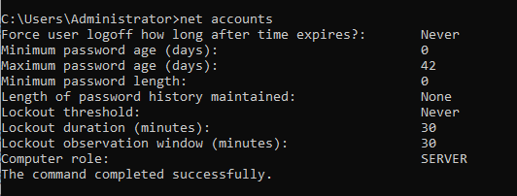
Viewing user accounts policies in windows – net accounts

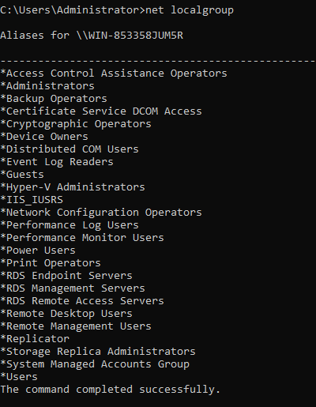

Viewing groups that comes with windows – net localgroup

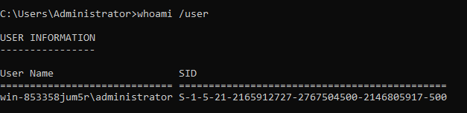
Windows work with SID (Security Identifier) of a
user to assign security privilege roles.
SID used to identify a security principal. A security
principal can represent an account, a user or a
process.
Security identifiers | Microsoft Learn

SAM (Security Account Manager) hive contains confidential information about accounts.

Windows\System32\config\SAM: SAM\Domains\Builtin\Aliases

Consists of group name and their associated users (SID’s)
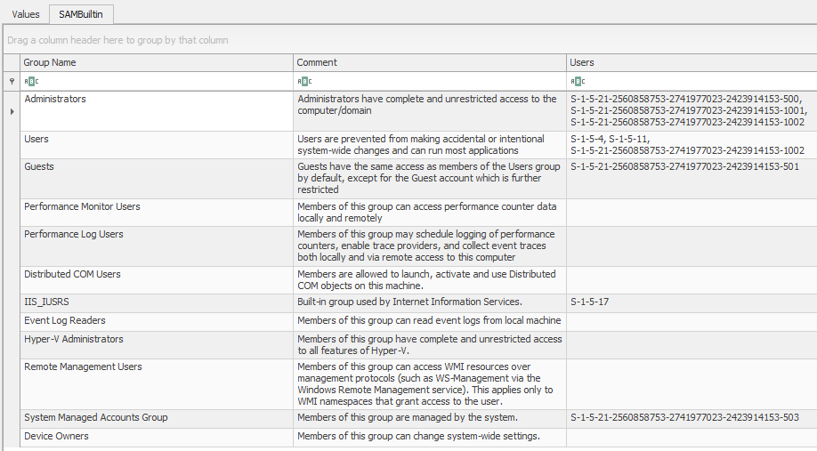

Windows\System32\config\SAM: SAM\Domains\Account\Users

This is a very important artefact as it stores two mappings:-
a. User id (Last section of S-I-D which is unique for every user created in the system) -> User name mappings
b. User name -> associated group mappings.

Windows only create profiles for users who logs in interactively.

rip.exe -r C:\Users\Administrator\Evidence_(kape)\Analysis\Registry_analysis\system\SOFTWARE -p profilelist

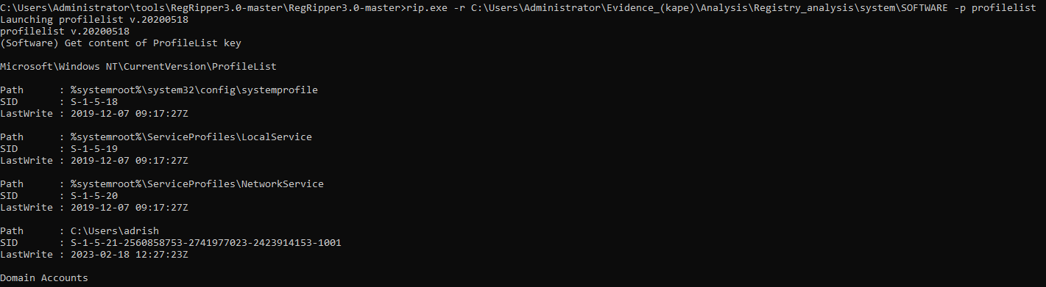
Forensic artefacts for user activity analysis

a. UserAssist
b. Recentdocs
c. ShellBags
d. Open/ Save MRU’s
e. Last-visited MRU’s

UserAssist is present in NTUSER.dat file. It keeps track of process’s executed during a particular time-frame.
NTUSER.DAT: SOFTWARE\Microsoft\Windows\CurrentVersion\Explorer\UserAssist

{CEBFF5CD-ACE2-4F4F-9178-9926F41749EA} – Key start with “CEB” keeps track of application, files, links and other objects.
2023-02-18 11:06:40Z
Microsoft.Windows.Explorer (10)
2023-02-18 10:15:51Z
{1AC14E77-02E7-4E5D-B744-2EB1AE5198B7}\services.msc (1)

{F4E57C4B-2036-45F0-A9AB-443BCFE33D9F} – Key start “F4E” keeps a list of shortcuts accessed. (lnk files).
2023-02-18 22:12:41Z
{0139D44E-6AFE-49F2-8690-3DAFCAE6FFB8}\Accessories\Snipping Tool.lnk (9)
{0139D44E-6AFE-49F2-8690-3DAFCAE6FFB8}\Accessories\Paint.lnk (7)
2023-02-18 11:06:40Z
{9E3995AB-1F9C-4F13-B827-48B24B6C7174}\TaskBar\File Explorer.lnk (8)

One more artifact to keep an eye on in the UserAssist section is the “Values with no timestamp” section.

NTUSER.DAT: SOFTWARE\Microsoft\Windows\CurrentVersion\Explorer\RecentDocs
RecentDocs is present in NTUSER.dat file. It keeps track of the most recent files accessed by the user with the help of extensions.
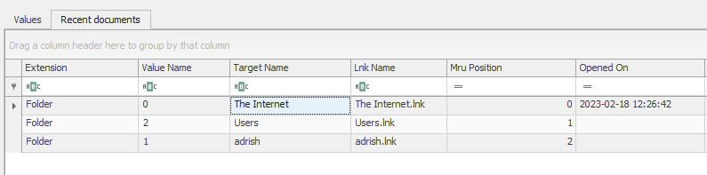
Shell bags analysis – Locations browsed by the user.
Consists of several artifacts
BAGMRU – Stores path of folders accessed. MRU stands for “Most Recently Accessed”.
UsrClass.dat: Local Settings\Software\Microsoft\Windows\Shell\BagMRU
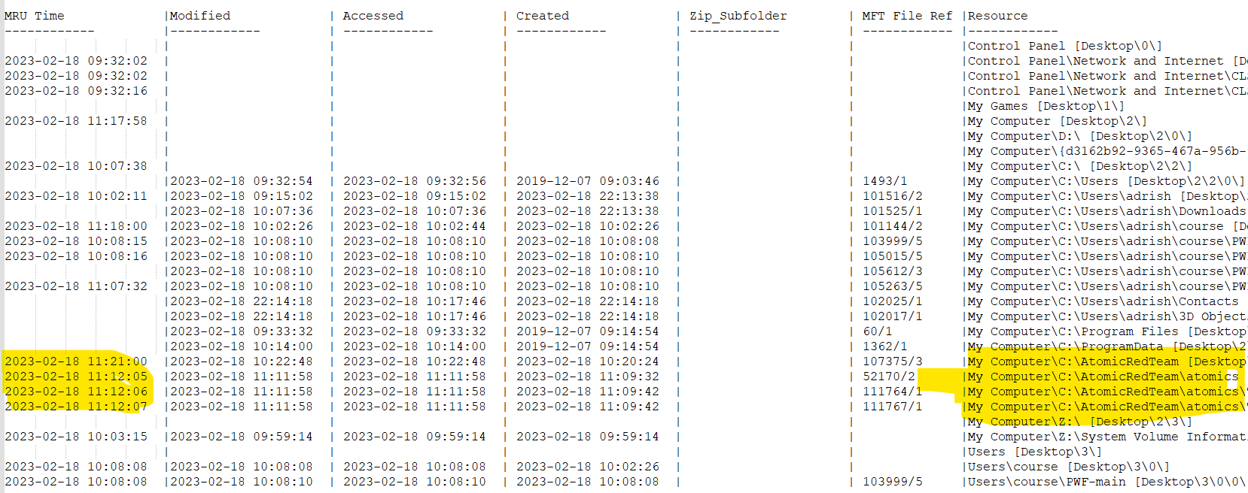
NTUSER.DAT: SOFTWARE\Microsoft\Windows\Shell
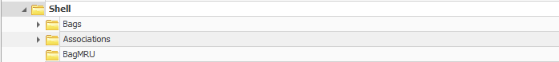

Bags shown in the above screenshot also provides information on folders accessed.
While conducting forensic analysis it is recommended to check all the above artifacts.

Other tools which can are specifically made for extracting information on shellbags are:-
Shell bag explorer (GUI) and SBECMD (cmd line tool).
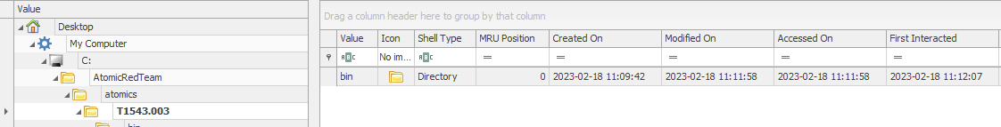
The Shell Bag explorer tool gives a detailed view of items accessed and their corresponding timestamps.
We can establish a timeline based on that.
Summary and timeline of forensics evidences
Time-line:-
Account Created: Sat Feb 18 10:22:56 2023 Z
Username: art-test [1002]
Last Login Date: Never

Sat Feb 18 10:23:17 2023 Z
Name = AtomicTestService_CMD
ImagePath = C:\AtomicRedTeam\atomics\T1543.003\bin\AtomicService.exe
Type = Own_Process
Start = Manual

2023-02-18 11:06:40Z
Microsoft.Windows.Explorer (10)

2023-02-18 11:06:40Z
{9E3995AB-1F9C-4F13-B827-48B24B6C7174}\TaskBar\File Explorer.lnk (8)

Analysis of artifacts related to NTFS

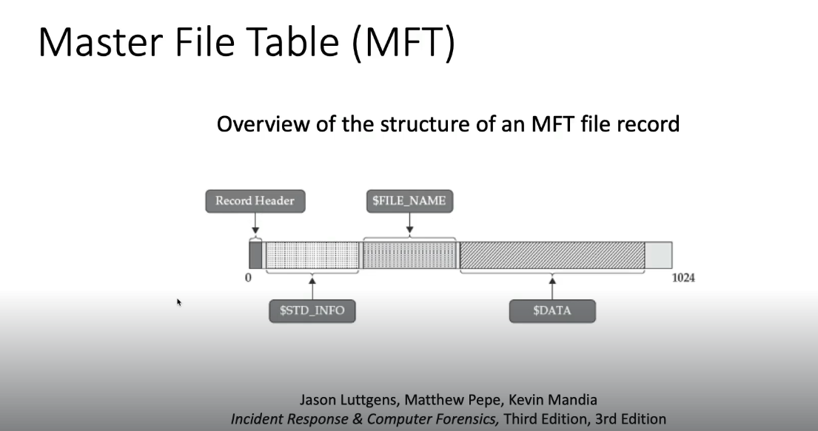
Record header stores the current status of the MFT record. It specifies that whether the file is in use or not or if the file exists or not in the system.
File name stores filename and timestamps (most reliable source of timestamp).
Data location of data.

$MFT record no. details – https://www.ntfs.com/ntfs-system-files.htm
MFT record for $MFT file itself.
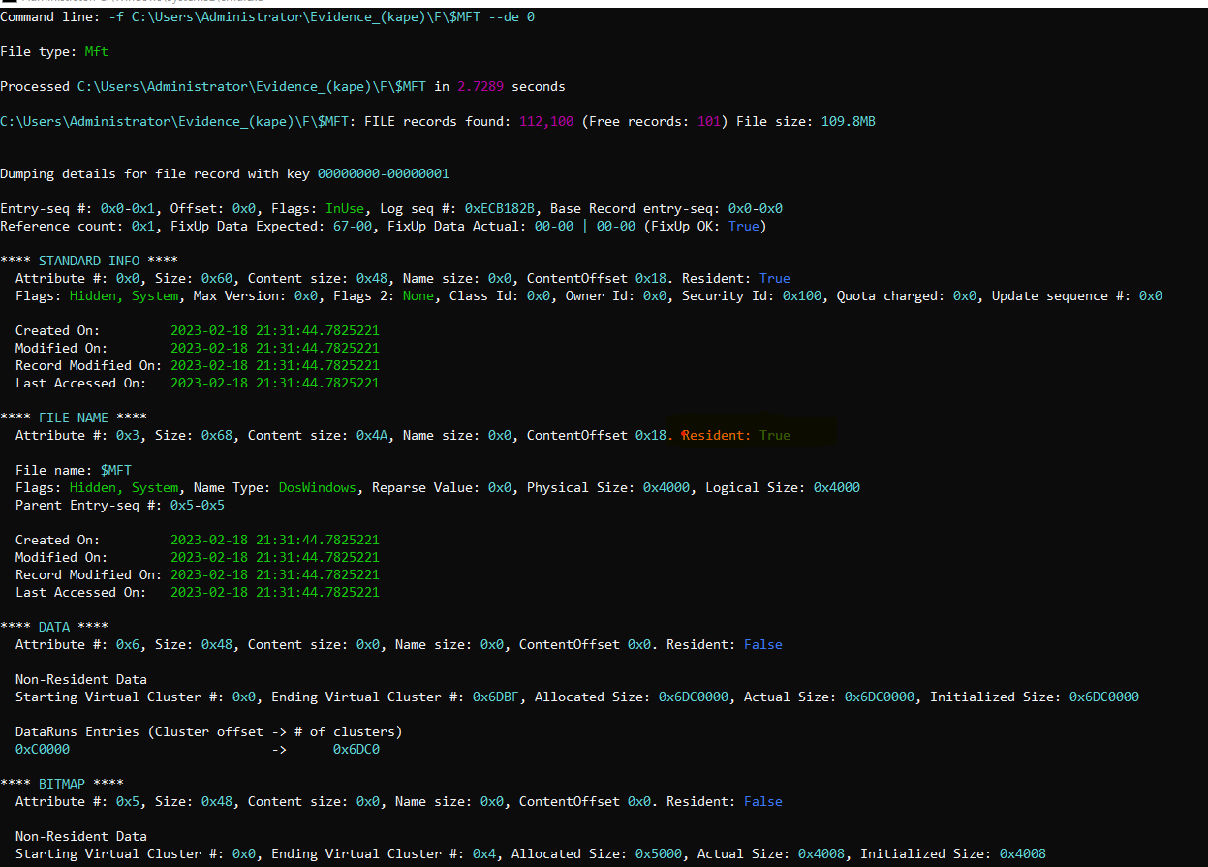
Some important attributes form the above screenshot for a MFT record.
Resident – true means the section ****STANDARD INFO**** or any other section is the resides in the particular entry. If the value is False there will be pointer which will store the address of the location where the information resides.

4 timestamps in 2 sections:-

Created on
Modified on
Record Modified on
Last Accessed on

The timestamps in the ****STANDARD INFO**** section changes when the file is modified or accessed etc. But the timestamp ****FILE NAME***** section only changes when there is any change in filename itself.
For parsing the entire $MFT and saving the contents we can use:-
MFTECmd.exe -f "C:\Users\Administrator\Evidence_(kape)\F\$MFT" --csv "C:\Users\Administrator\Evidence_(kape)\Analysis\NTFS_File_system_analysis\MFT.csv"
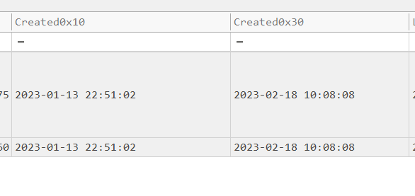

Created (0×10) – timestamp of standard info section & Created (0×30) – timestamp of filename section.
MACB timestamps
All timestamps should be taken form Standard info section.
m – modified
a - accessed (last accessed)
c – changed (change in $MFT record itself)
b - birth (created)
https://andreafortuna.org/2017/10/06/macb-times-in-windows-forensic-analysis

So, during analysis you can use analyzeMFT.py in order to check if the $FILE_NAME time occurs after the $STANDARD_INFORMATION Creation Time.

Time-stomping – Altering / tampering timestamps of a forensic artefact.

Finding evidence on deleted files
$MFT stores record of all the files in the system which are and not are in use. So we can look for file which have “In Use” flag unchecked.
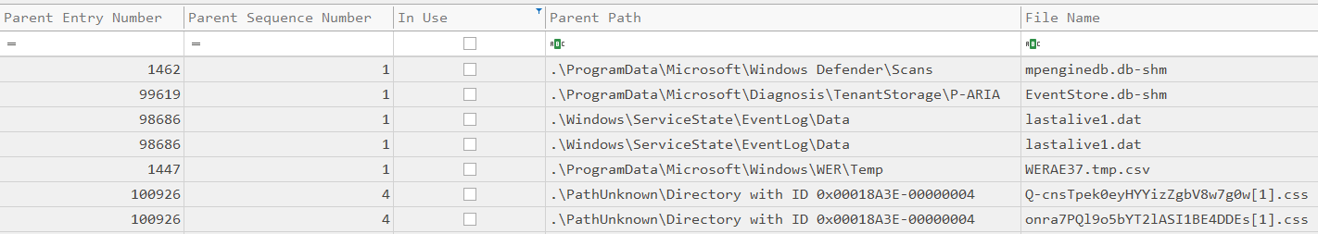
Another very important source of delete files is “UsnJrnl”
path - $Extend\UsnJrnl
The UsnJrnl has two sub-files. When we extract artifacts with KAPE it divides the file into sub-parts hence making the analysis easier.
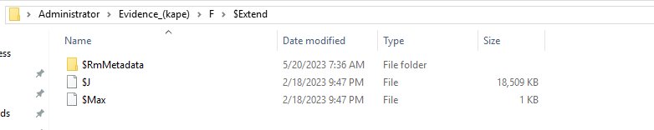
$J and $Max. We will be looking into the $J data stream. We will use MFTECmd to parse this file.
MFTECmd.exe -f "C:\Users\Administrator\Evidence_(kape)\F\$Extend\$J" -m "C:\Users\Administrator\Evidence_(kape)\F\$MFT" --csv "C:\Users\Administrator\Evidence_(kape)\Analysis\Deleted_files_usrnjnl"

The $MFT file is also referenced along with the $J using -m parameter. The $J file gives us details on the operation that have been executed on a file in a serial order.
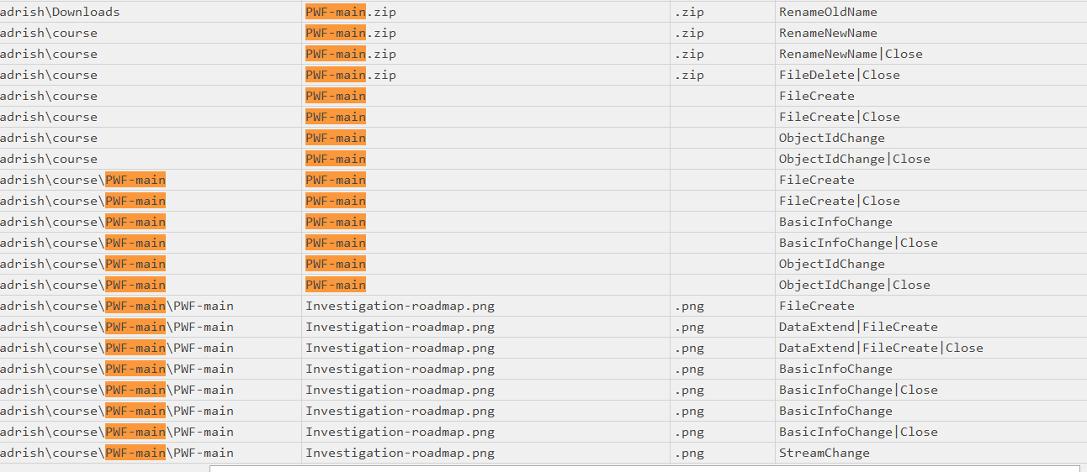
In SS, we can see all the
operations that PWF-Main file
has gone through while being
extracted from zip.
The order of extraction is clearly
when Sequence column is sorted.

Files which are not found directly in $MFT but in $J, the entry no of the later can be used to look up that file in $MFT.
If it’s marked as “In use” it us possibly because it’s overwritten.
Analysing execution artefacts

Background Activity Monitor
Path - SYSTEM: ControlSet001\Services\bam\State\UserSettings
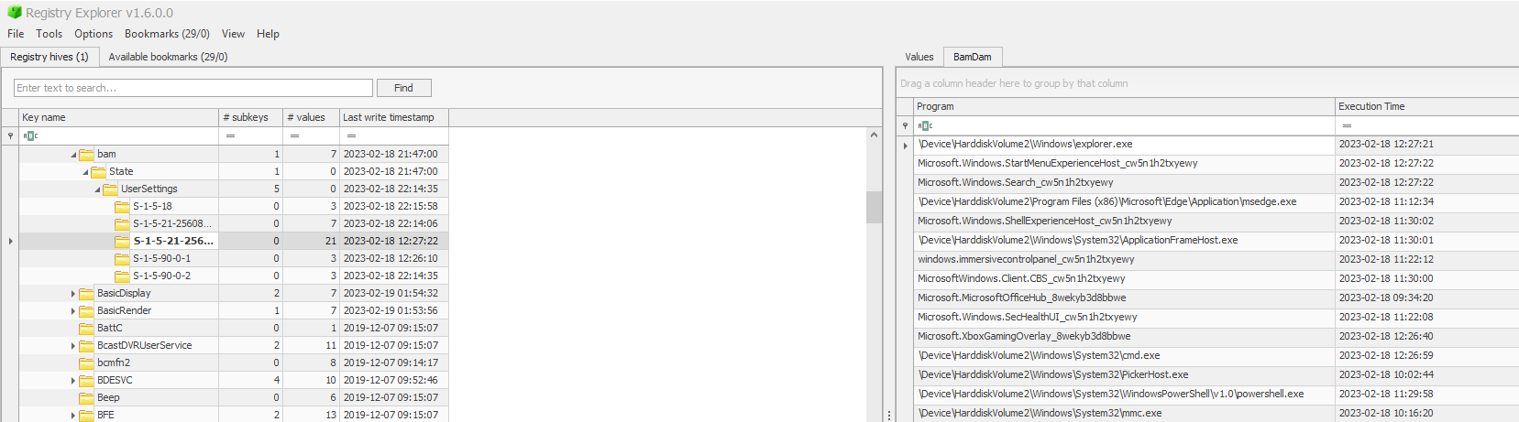
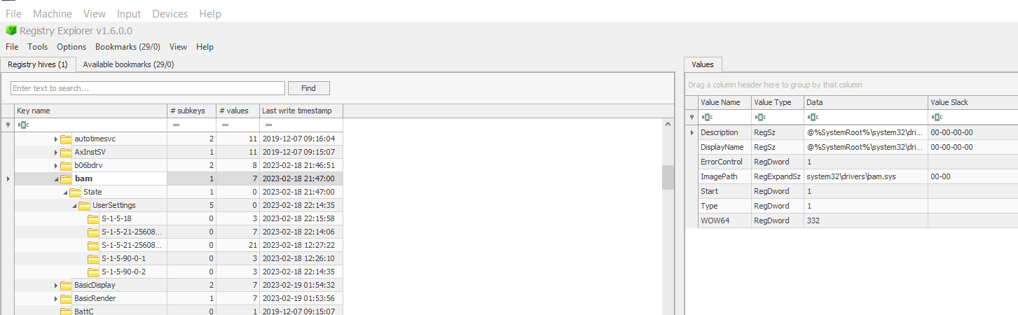
Program name for BAM:- system32\drivers\bam.sys
BAM mostly records execution artefacts run via “.exe” files. Reg-ripper also has similar output which is generated via the BAM plugin.
Records from BAM are rotated so information about all executables might not be available.
If the executable is removed from the system followed by system reboot the BAM records might be deleted as well.
So, BAM might not give the full context of execution but still remains an important artefact for analysis.

Application Compatibility Cache (ShimCache)
The application compatibility cache is used for storing backward compatibility data of applications.
It also stores the metadata of the file and it’s execution time-frames.
Path – SYSTEM: ControlSet001\Control\Session Manager\AppCompatCache
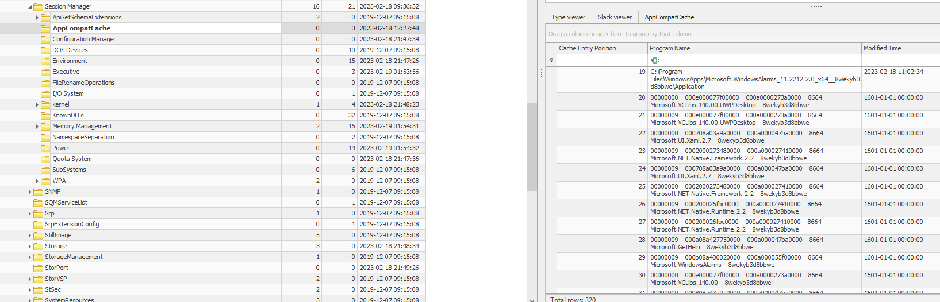
The Shimcache only contains the information prior to the system’s last startup, as current entries are stored only in memory .
Don’t sort the entries of ShimCache output via file modified timestamp, rather use the cache entry position.
The information can also be obtained through reg-ripper plugin AppCompatCache.
Another tool that can be used is “AppCompatCacheParser” from the Eric Zimmerman suite of tools.

Amcache
C:\Windows\AppCompat\Programs\Amcache.hve – path to amcache hive. This hive can be loaded in the Amcache parser tool for detailed analysis.
It has SHA1 has for executables which will help us do OSINT (VirusTotal) - C:\Users\Administrator\Evidence_(kape)\Analysis\Execution_artefacts
https://dfir.ru/2018/12/02/the-cit-database-and-the-syscache-hive/
Data in the “Amcache” hive is not entered directly once any program is executed. A scheduled task called the “Microsoft Compatibility Appraiser” runs at regular intervals which is responsible for data entry in the “Amcache” hive.
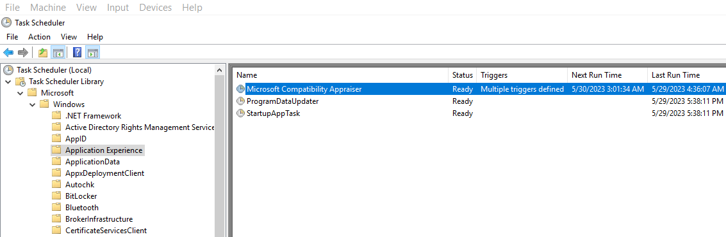
The Last-write timestamp attribute obtained after parsing the amcache.hve file cannot be taken for as the last execution time of that executable.

Prefetch
Path – C:\Windows\Prefetch
Windows store a prefetch file for every program that is executed.
The naming format of the prefetch file is – ATOMICSERVICE.EXE-94EEF3DF.pf “ <filename-hex of location>.pf”
For analysing prefetch files we will be using the “PECmd.exe”
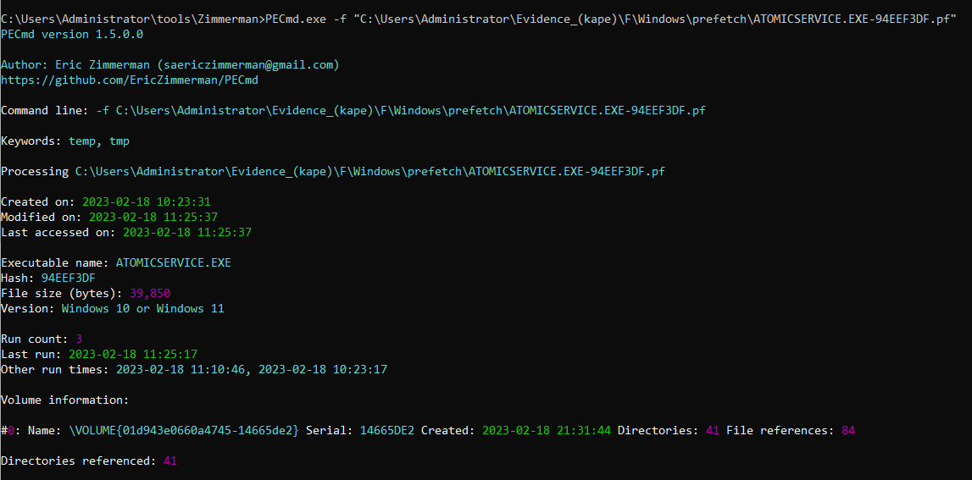
Following is the record for a prefetch file.
Important areas – Run count, directories referenced, files referenced.
sc.exe artefact creates windows services to be executed.

Persistence mechanisms
Auto-run keys analysis with reg-ripper and registry explorer
User specific run keys:-
HKEY_CURRENT_USER\Software\Microsoft\Windows\CurrentVersion\Run
HKEY_CURRENT_USER\Software\Microsoft\Windows\CurrentVersion\RunOnce
System specific run keys:-
HKEY_LOCAL_MACHINE\Software\Microsoft\Windows\CurrentVersion\Run
HKEY_LOCAL_MACHINE\Software\Microsoft\Windows\CurrentVersion\RunOnce

Applications referenced in the run keys are checked by windows during system boot-up and runs it.
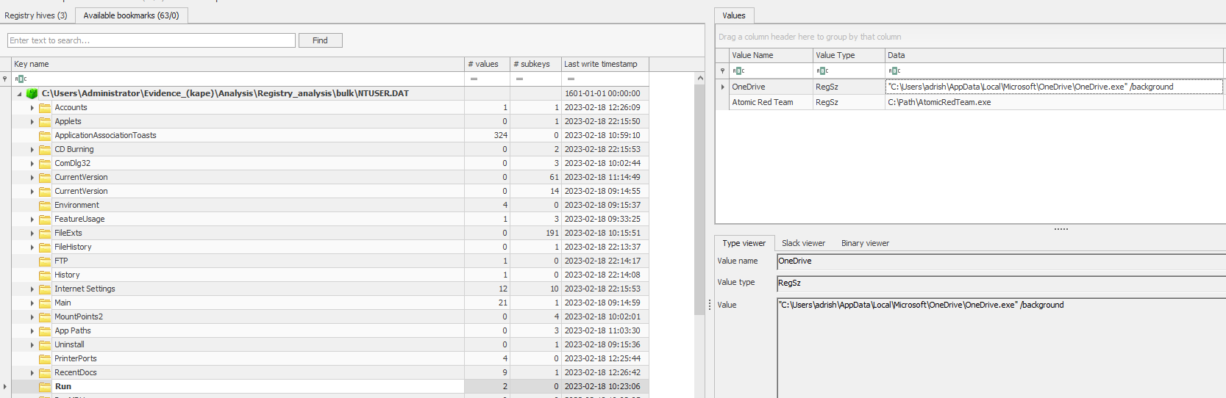
Following applications will be executed after windows boot-up.
If the path present in the key is not present in the system, the persistence mechanism is not going to work. The original path of the file can also be searched from artefacts such as $MFT.

https://attack.mitre.org/techniques/T1547/001/

Windows services analysis
The easiest way to see services and process’s running on a system is through the windows task manager.
But if we want check out details like installation time, we have to dig into the registry hive.
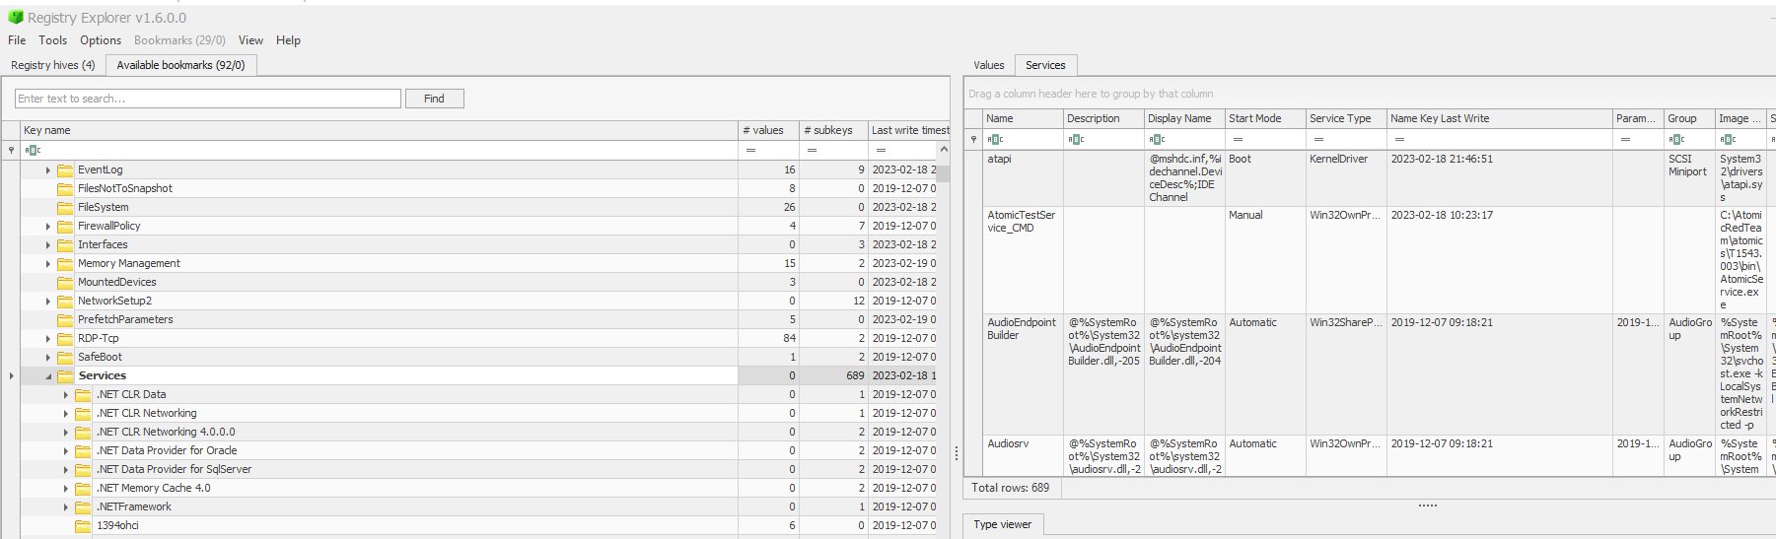
SYSTEM: ControlSet001\Services
The sub-key services also has information on whether the program is executed manually or set to run during boot or automatically after system starts.

Startup folders
Programs which are executed on startup can also be used for persistence in the system. We can view it from the task manager of any system.
The windows system stores startup programs in 2 folders, one for the OS itself and another for user specific programs.

C:\Users\[Username]\AppData\Roaming\Microsoft\Windows\Start Menu\Programs\Startup
C:\ProgramData\Microsoft\Windows\Start Menu\Programs\StartUp
There can be a case where the statup folder is missing or is empty, in that case we can also analyse the $MFT to find about any transactions that might have been deleted.
Scheduled tasks
These are tasks scheduled in the system by user or windows. We can view the list of configured scheduled task using CMD.
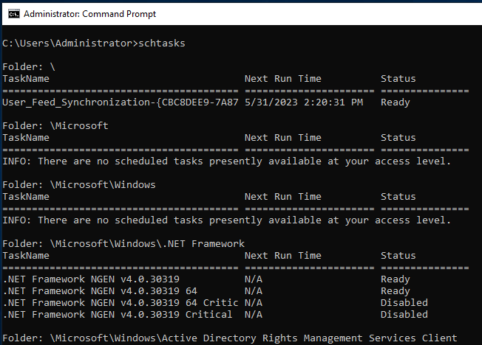
Schtasks displays information about scheduled tasks in the system.
We can find details about scheduled tasks in the registry hive as well.
The tasks subkey stores information about task runs.
SOFTWARE: Microsoft\Windows NT\CurrentVersion\Schedule\TaskCache\Tasks
The tree subkey stores details about all the tasks in the system.
SOFTWARE: Microsoft\Windows NT\CurrentVersion\Schedule\TaskCache\Tree
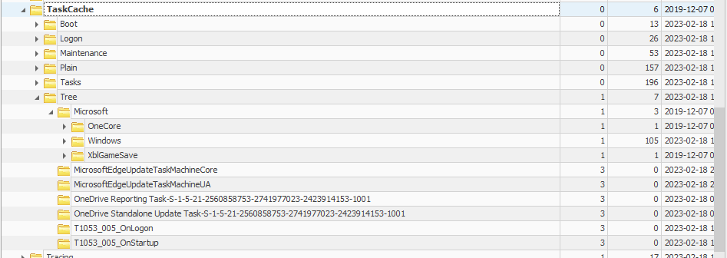
The tree subkey gives the same information as “C:\Windows\System32\Tasks”. The task sub-key also stores information about the author of the task.
Tasks are stored in XML format inside the above folder. We can view details like execution action of the task.
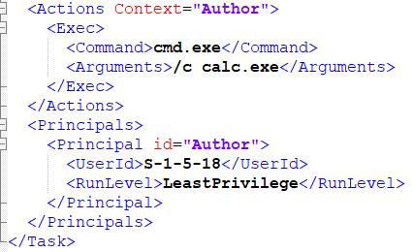
In the SS we can see the execution of this task
T1053_005_OnStartup will open CMD which in
turn will open calc.exe.
We can also see a system user has been assigned to run the
task which is part of core OS.

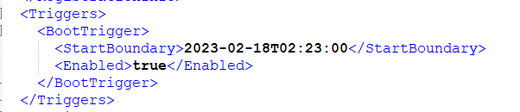
Another important artefact is the trigger of the task
we it is a BOOT trigger which means the task will be
executed anytime when the system boots up.

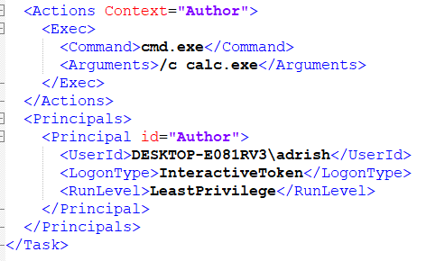
In the SS we can see the execution of this task
T1053_005_OnLogon will open CMD which in
turn will open calc.exe.
We can also see a human user has been assigned to run the
task.

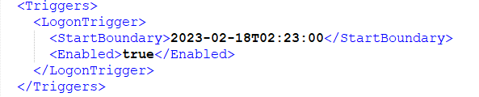
We can see the trigger for this task is user logon. So whenever user “adrish” logs on T1053_005_OnLogon will be executed.

Auto-run sys internal tool
This utility, which has the most comprehensive knowledge of auto-starting locations of any startup monitor, shows you what programs are configured to run during system bootup or login, and when you start various built-in Windows applications like Internet Explorer, Explorer and media players.
These programs and drivers include ones in your startup folder, Run, RunOnce, and other Registry keys. Autoruns reports Explorer shell extensions, toolbars, browser helper objects, Winlogon notifications, auto-start services, and much more. Autoruns goes way beyond other autostart utilities.
https://docs.microsoft.com/en-us/sysinternals/downloads/autoruns

Once we startup the auto-runs utility we can load offline disks into it for analysis.
First requirement is mounting the tool with Arsenal Image mounter.
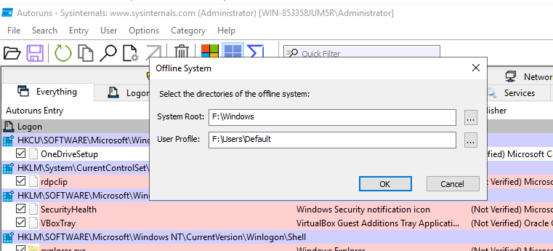
Specify the directories in the following manner. We can choose any particular user profile of our choice.
This can give a quick but not detailed overview of a system. Many forensic artefacts are missing from the tool when we load an offline disk.

Event LOG Analysis
https://www.linkedin.com/posts/archan-choudhury-b4a719b7_dfir-incidentresponse-windowsforensics-activity-6988497105396928512-Up4p?utm_source=share&utm_medium=member_desktop

Event logs stores all the events that are happening inside the system. e.g. - Login events, application runs etc.
Windows event log cheat sheet – Windows Security Log Encyclopedia (ultimatewindowssecurity.com)
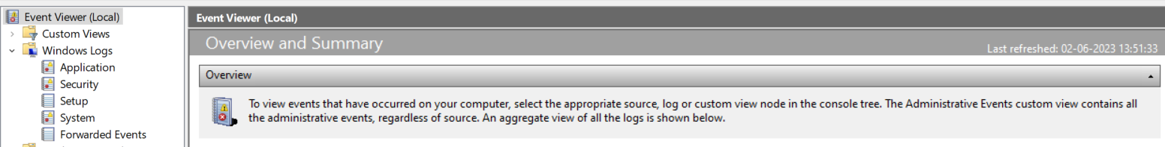
Windows provides native application, which is event log viewer to view event logs. The SS represents the major category of event logs that are recorded by the system.
Event log can be analysed with 2 tools:-
Event log explorer
EZ’s EvtxCMD

Windows defender Event LOG analysis
Source Event IDs Description
Microsoft-Windows-Windows Defender 5000 Defender enabled
5001 Defender disabled
We can load up the windows defender evtx file -
Windows\System32\winevt\logs\Microsoft-Windows-Windows Defender%4Operational.evtx
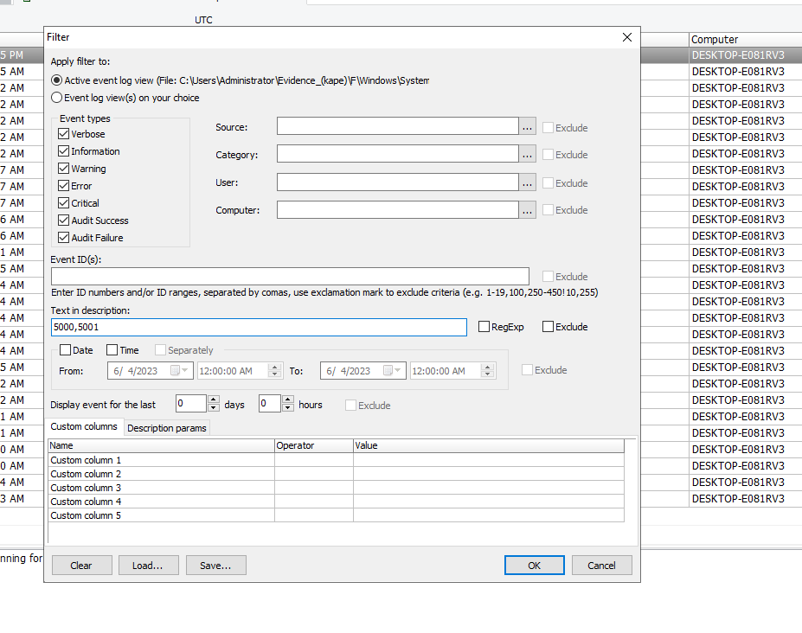
We can manually filter out events in event log explorer as shown above. In this case we are interested in 5001 and 5000.

Post-filtering out we can see event 5001 which indicates that windows defender’s real-time service was turned off.
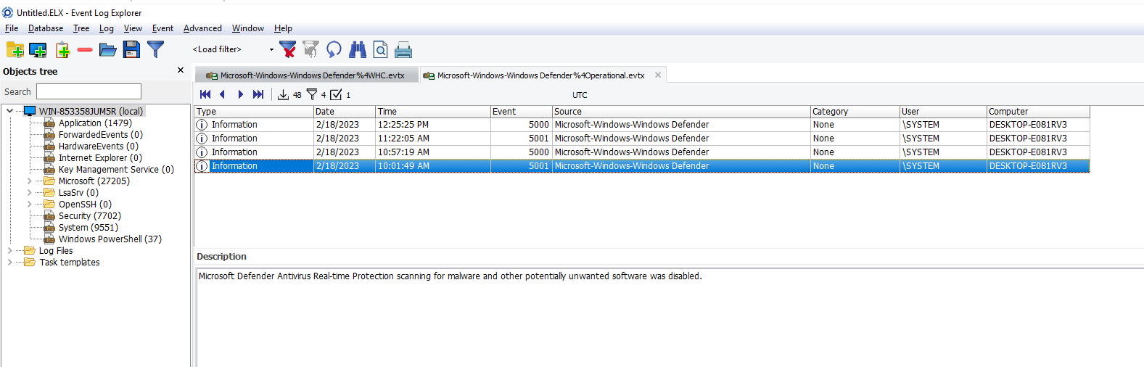
Service installs using SYSTEM Event log
Events to look out for:-
System 7045 A new service was installed
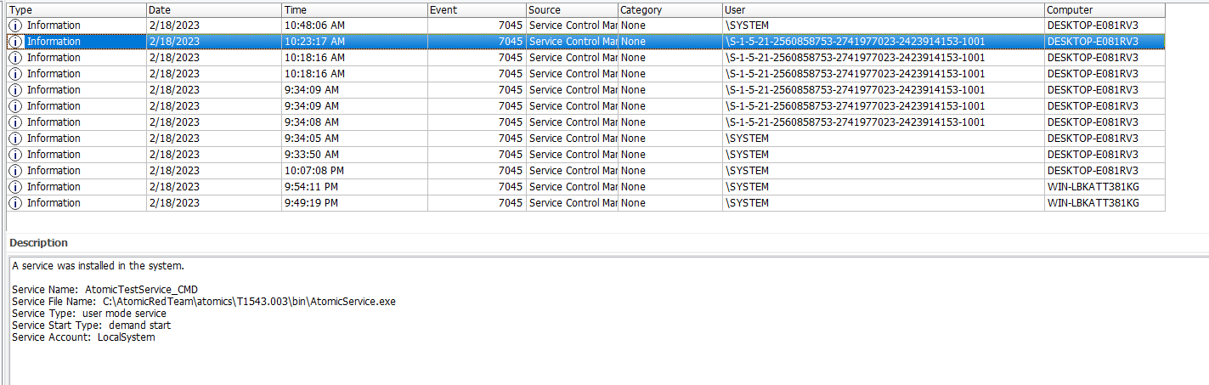
We can see the event id – 7045 for an application Atomic service.exe

Authentication events
Authentication events can be found within the SECURITY event log file.
Security 4624 An account was successfully logged on
Logon types gives us details about the type of logon. For eg :-
0 | System | Used only by the System account, for example at system startup.
2 | Interactive | A user logged on to this computer.
3 | Network | A user or computer logged on to this computer from the network.
4 | Batch | Batch logon type is used by batch servers, where processes may be executing on behalf of a user without their direct intervention.
5 | Service | A service was started by the Service Control Manager.
7 | Unlock | This workstation was unlocked.

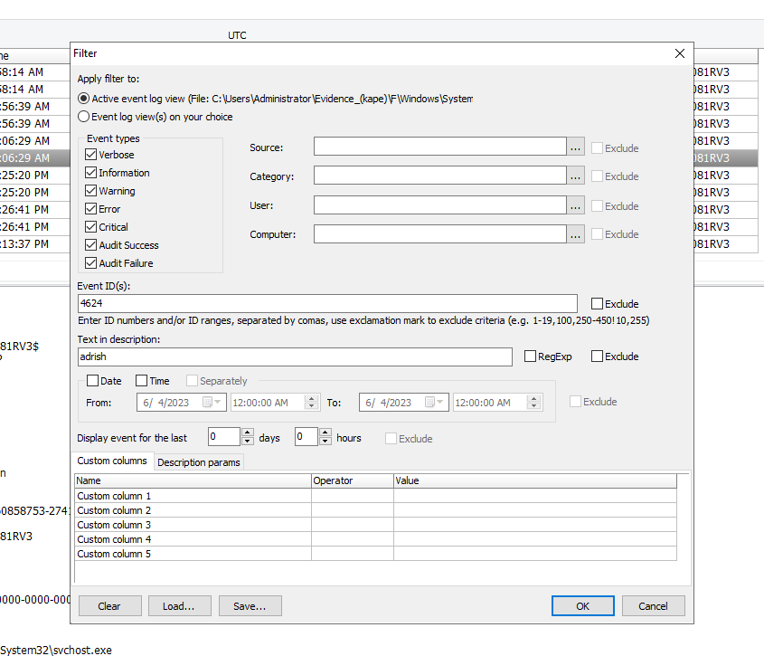
We can use multiple filters in the window event explorer. In the above SS we are searching for logon events of the user adrish.
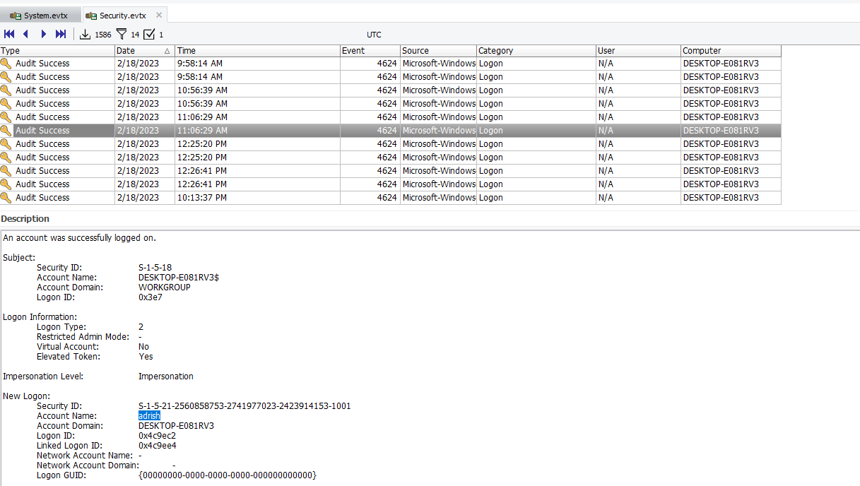
We can also see the login from the Logon type – 2, was an interactive login.

https://learn.microsoft.com/en-us/windows/security/application-security/application-control/user-account-control/how-it-works

In the above SS we can see the activities filtered for a logon id which can be found in the description of a event record.
We can see the activities till log-off event.
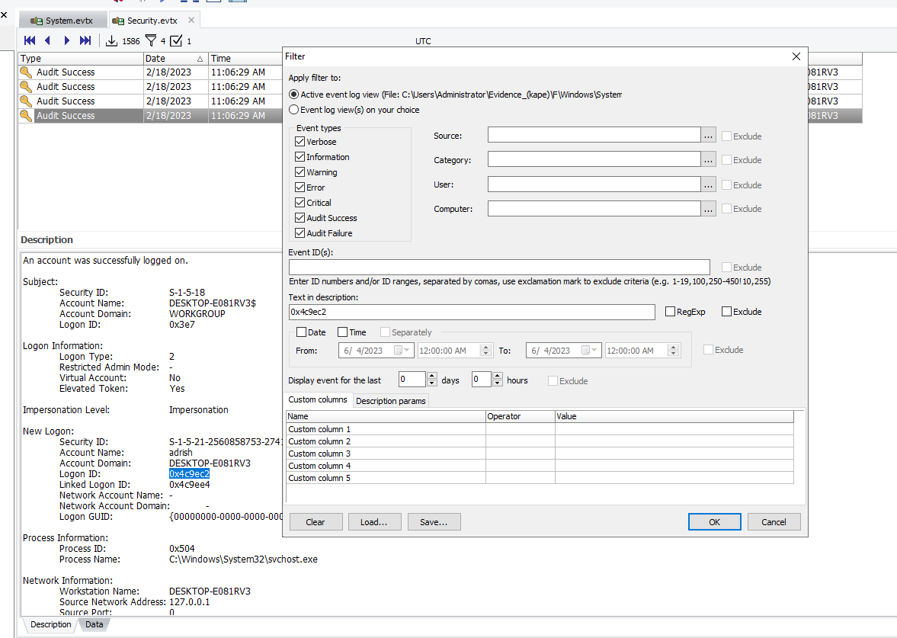

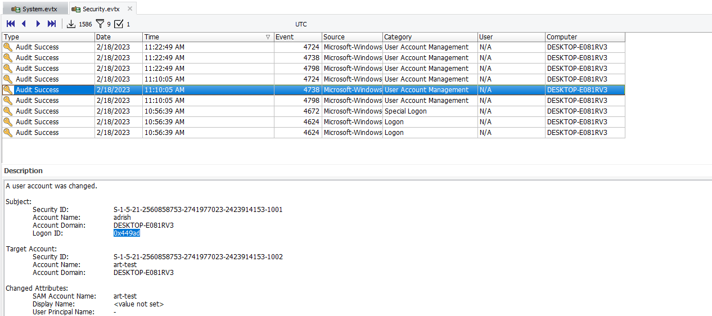
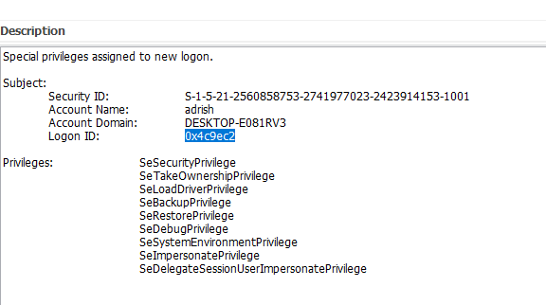
The special logon event 4672 is a useful artefact as it stores information on the capability of the user.

Events from a particular logon id.
In the above screenshot we can see a user account was changed – art-test.
When analysing the logs of Authentication events we should focus on events that have User Account Management and Security Group Management as they may reveal information for users created, user account changed, credential change and addition/removal of users from a particular security group.
We can search for events surrounding an account login by filtering the data with the logon id.

PowerShell Event LOG’s
Windows PowerShell 400 Engine state is changed from None to Available
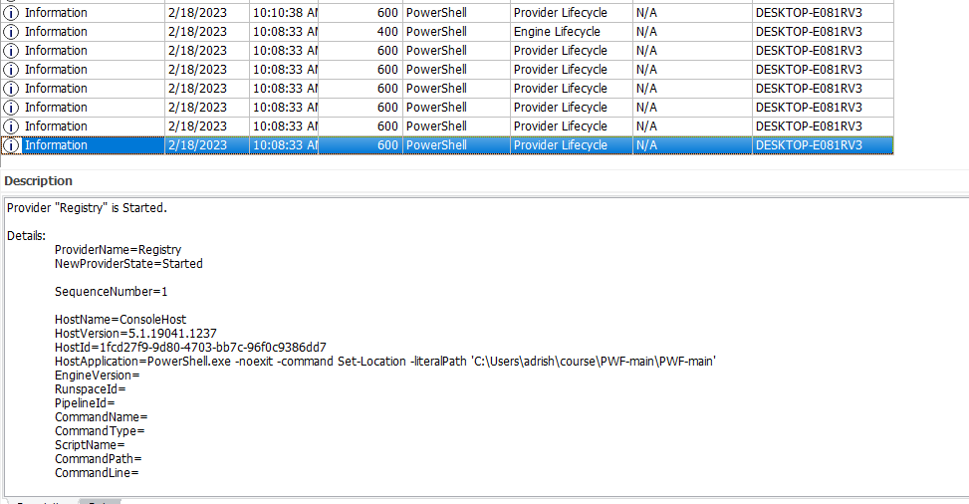
When a powers shell instance starts it does so by defining variables such as providers and there are sequence number assigned to it.
The sequence number increases as the PowerShell engine status is changed form None to available as shown below.
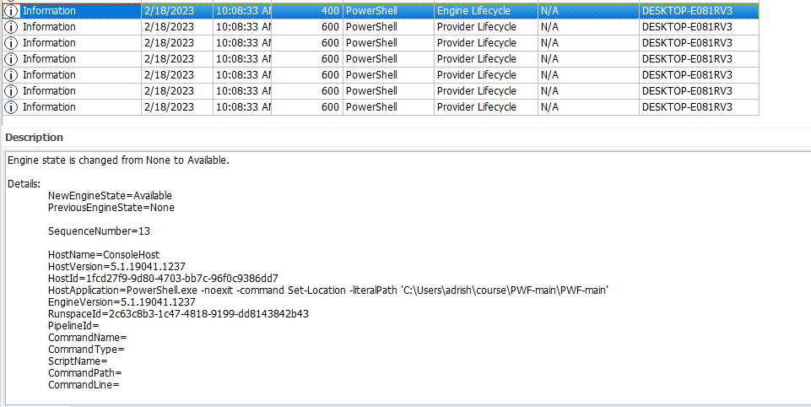
The PowerShell engine is stopped at 403 event.
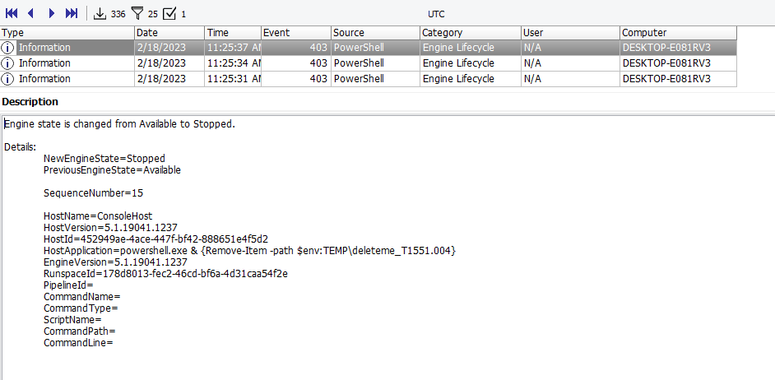
Important events to look out for while capturing malicious events via PowerShell – 4104, 4103. These captures Payloads as well.

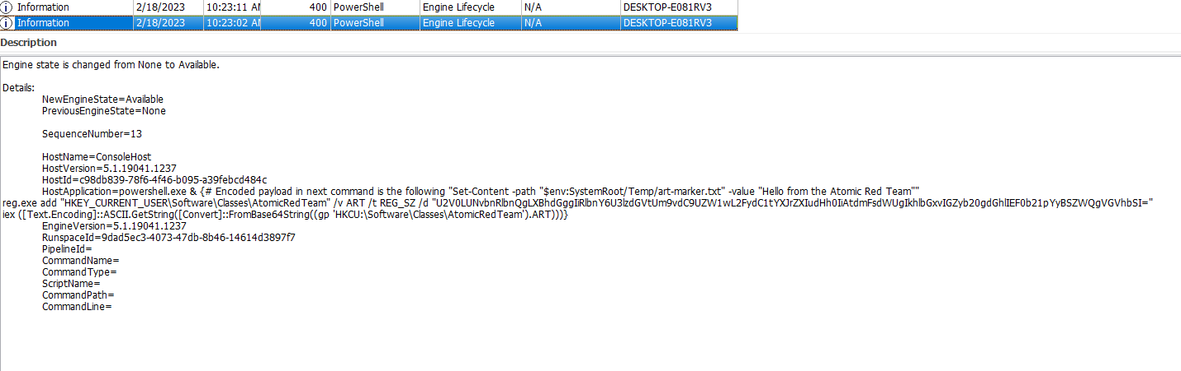
The above is an example of file less attack. We can see the power-shell command line is trying to add a registry key in the SOFTWARE hive and the entire content of the key is passed as an argument and not via any file.
Converting the above base64 encoded payload into plain text we can see the following:-
Set-Content -path "$env:SystemRoot/Temp/art-marker.txt" -value "Hello from the Atomic Red Team"
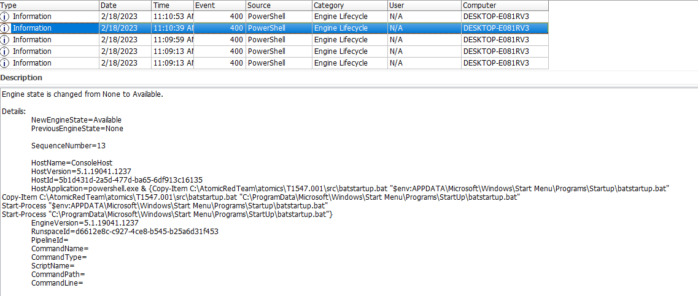
Setting path for persistence. Copying batstartup.bat to startup folder, which was discussed in persistence section.
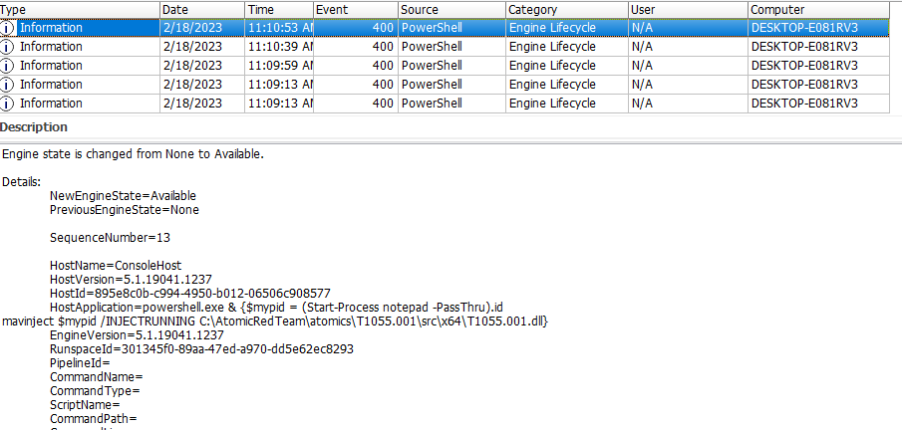
In the above SS, we can see notepad process is started and mavinject is being used to push T1055.011.dll code by using the process id for notepad as an argument.
Event logs can also be used for finding evidences on deleted files.
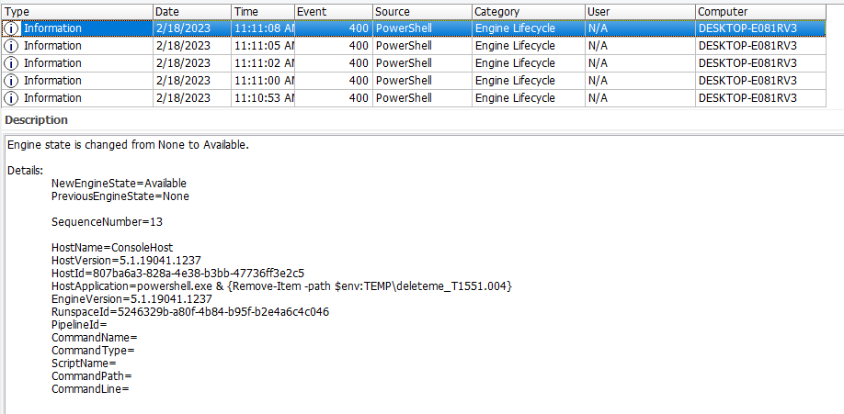
Sysmon event logs
Microsoft-Windows-Sysmon
1 Process creation
3 Network connection
11 File create
12, 13 Registry events
22 DNS query

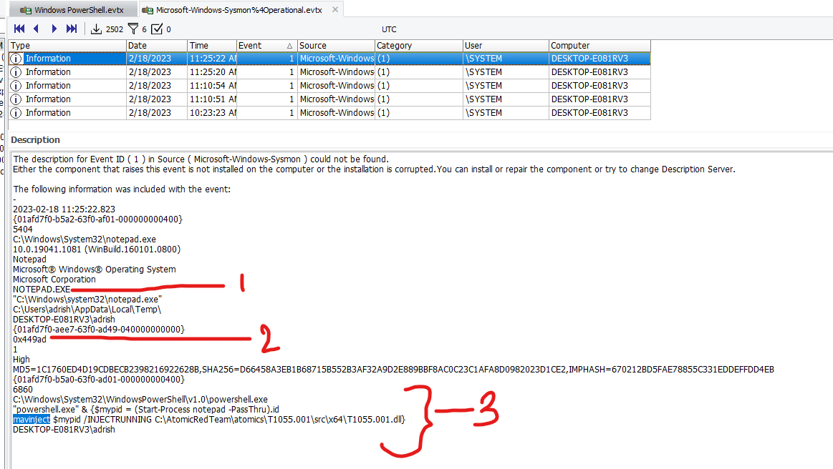
3 important artefacts to look out for while exploring process creation event (1): -
1. Child Process – notepad
2. Logon id – 0x449ad – This can be further used to search events executed in the context of this id from security.evtx logs.
3. Parent process – mavinject – Process injection event discussed in PowerShell event (400) section.
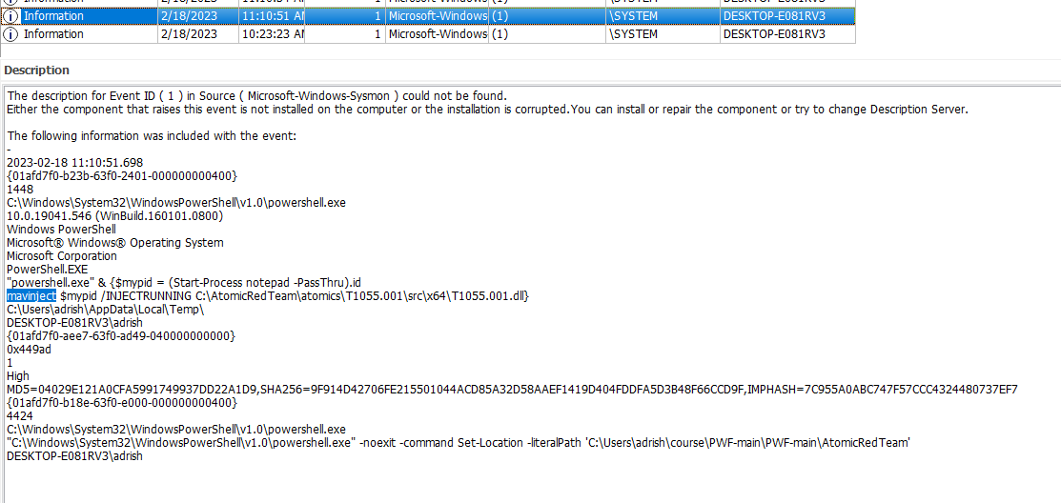
Parent process for mavinject.
Take note on important pid’s which can be used while conducting memory forensics.

Memory forensics with volatility
Installation of volatility
# Update sources
sudo apt-get update
# Install PIP3
sudo apt install python3-pip
# Install Volatility3 and capstone
pip3 install volatility3
pip3 install capstone
# Refresh bash
source .profile

Important artefacts to look at for memory forensics:-
hiberfil.sys
pagefile.sys
swapfile.sys
We will be using our windows.raw file for analysis. This is the memory image that was taken post attack.
Major difference between volatility3 and volatility2 is version 3 doesn’t need windows profile to work. If the forensic workstation is connected to internet vol3 can figure out profile by itself.
If the system is not connected to internet then symbol tables for various OS needs to downloaded in the workstation.
https://github.com/volatilityfoundation/volatility3#symbol-tables
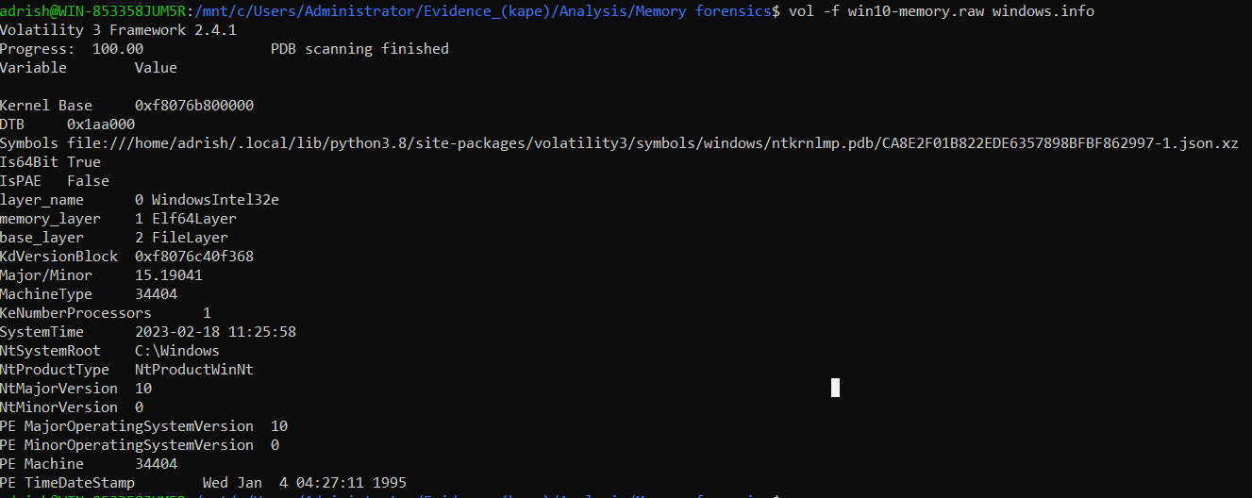
vol -f win10-memory.raw windows.info
-f –> windows memory filename
-windows.info -> Plugin for taking out windows information
In the above SS we can see information regarding the OS, such as:-
Whether OS is 64-bit—Is64Bit
Version no – 15.19041 (Major/minor) > we can re-assert this info from the 1st section of our registry analysis.
Registry: HKLM\Software\Microsoft\Windows NT\Currentversion\
ProductName Windows 10 Home
ReleaseID 2009
BuildLab 19041.vb_release.191206-1406 - as we can see the build version 19041 is same as mentioned

NtMajorVersion – 10 (as the OS is windows 10)

We can list process’s in volatility using pslist plugin.
Malware's can hide process’s form windows by unlinking it from the process list.

If we look into the “pstree” dump we can see that there are 2 instances of notepad.

In the above SS, we can see “notepad.exe” was running & the parent process id 1448 which denotes “Mavinject” as seen in previous section during event log analysis.
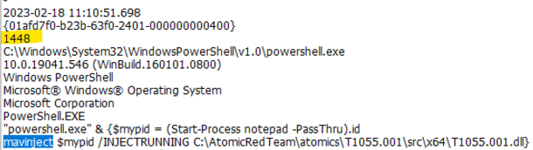

The parent id of the process 1448 or the parent id of 1448 i.e. the PowerShell process doesn’t exist in the process list.
We can get details of a particular process id by mentioning the pid in cmd line.

vol -f win10-memory.raw windows.pslist --pid 6896
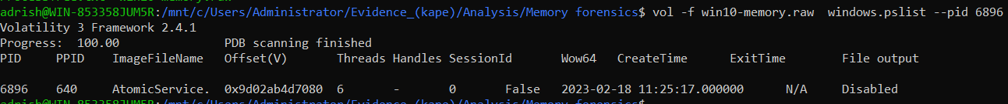
To dump the details of the above we have to add “--dump” parameter to do so.
vol -f win10-memory.raw windows.pslist --pid 6896 --dump

There are couple of ways to analyse the dump :-
a. Strings (strings filename.dmp)
b. Calculate hash and see it in Virus total.

DLL’s or Dynamic Link Libraries are helper files that process’s use to execute certain functionalities. All windows process’s have associated DLL’s and these can be used to threat actors to load malicious process’s in the memory.
We can check the list of DLL’s loaded by a process with the help of “windows.dlllist” plugin.

Note – U can pass multiple pid’s in the pid parameter by “--pid <pid1> <pid2>”

vol -f win10-memory.raw windows.dlllist --pid 6896

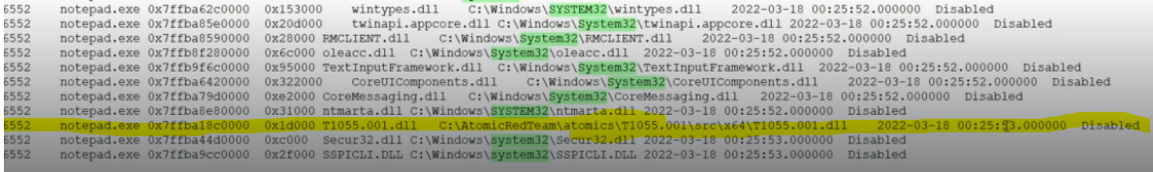
In the dump we can see that one of the DLL’s highlighted above T1055.001.dll which is not loaded out of the system32 directory.
While extracting dumps of malicious DLL, ensure that the folder storing the dumps is in exclusion list for windows defender.
Once dumped, u can use the strings utility. strings dll/<name>.dmp | more

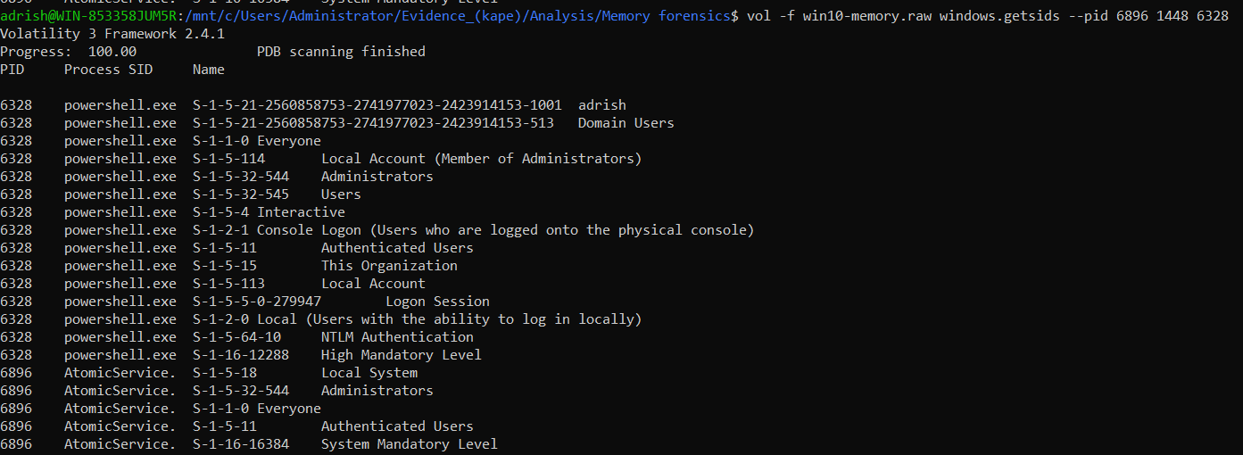
We can detect owners of process’s and get their SID’s through windows.getsids.
This enables us to spot out accounts and users that have been used to execute process’s.

Detecting malicious registry keys from memory
We can use the windows.hivelist plugin to list out the affected hives.
vol -f win10-memory.raw windows.registry.hivelist
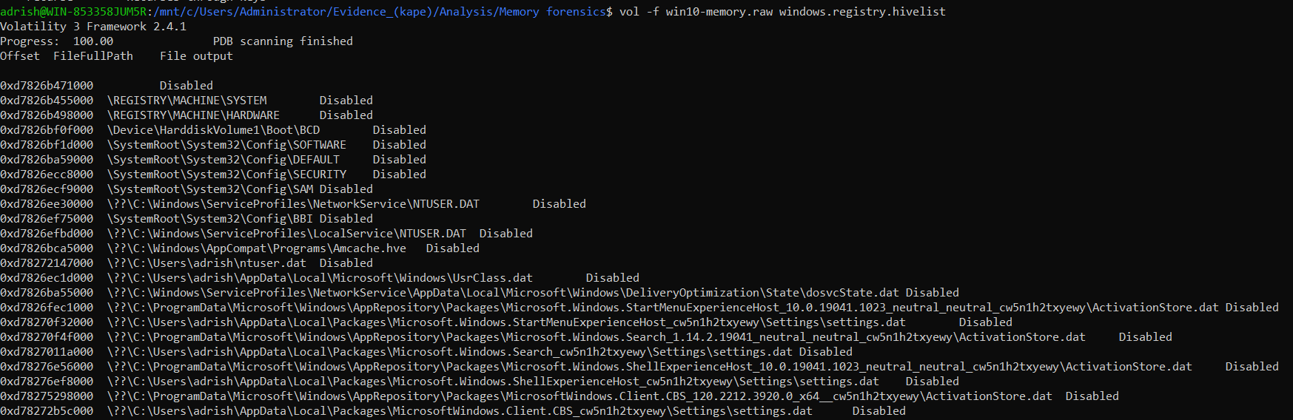
For this demo we will use HKCU hive for analysing malicious keys. The above output lists out the offsets of each hive.
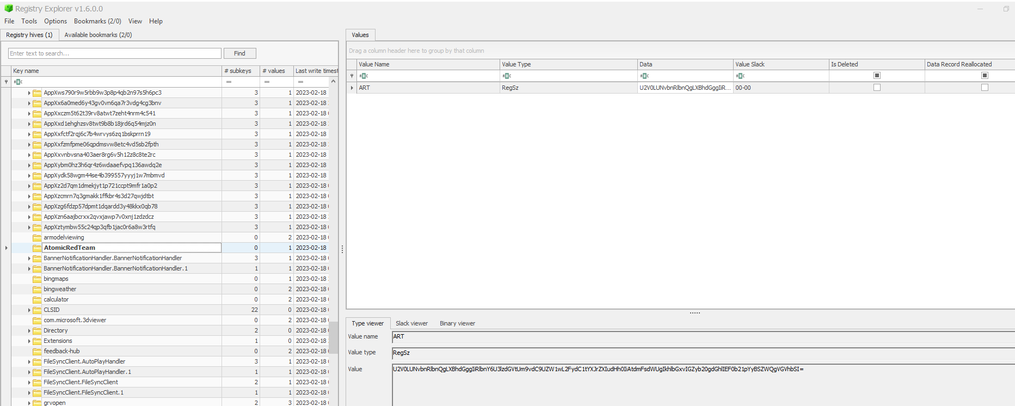
We can see a base64 encoded payload placed in the HKCU registry.
vol -f win10-memory.raw windows.registry.printkey --offset 0xd7826ec1d000 --key AtomicRedTeam
Offset value for HKCU. Evidence of the same was also found while analysing winevents 400 which confirms this was set by PowerShell script.
Super time-line analysis
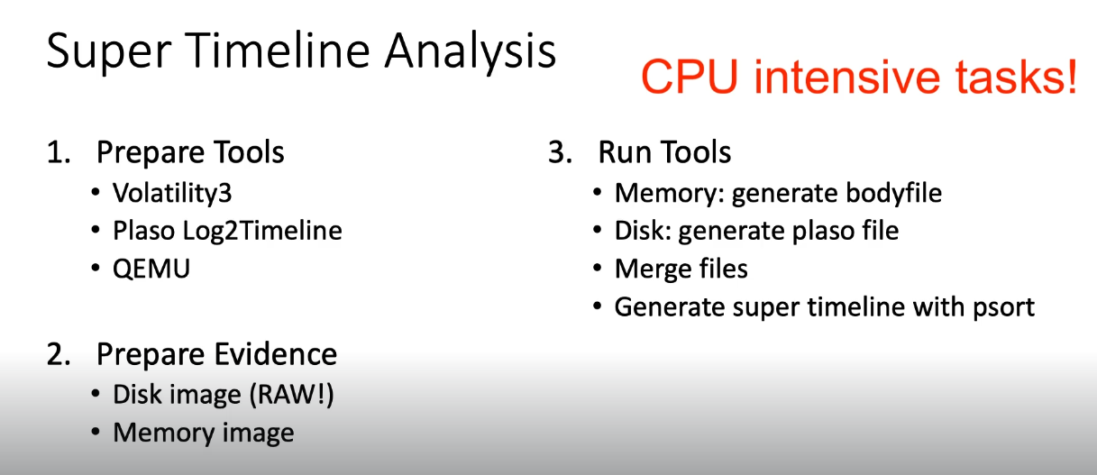
4. EZ Time line explorer

Installing tools – https://bluecapesecurity.com/build-your-forensic-workstation/

# Install qemu tools – Quemu tools is used to convert the disk image (.vhd) to (.raw) format.

Installation instructions and disk format conversion
# Add the plaso GIT repository
sudo add-apt-repository ppa:gift/stable
# Install plaso
sudo apt-get install plaso-tools
# Install qemu tools
sudo apt install qemu-utils
# Converting the VHD to RAW with qemu
qemu-img convert -O raw win10-disk.vhd win10-disk.raw

Memory Time line generation with Volatility3
Volatility is used for analysing memory images and extract forensic artefacts. Volatility has a wide variety of plug-ins which can be used to extract the same.
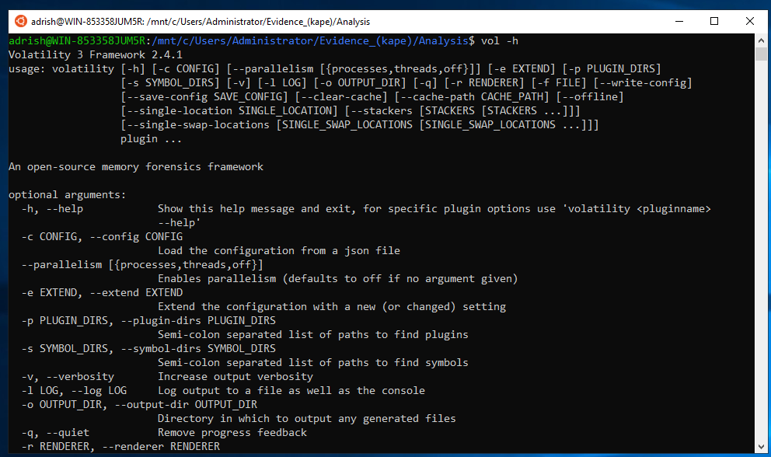
Body file is created with volatility “https://wiki.sleuthkit.org/index.php?title=Body_file” helps in establishing the time line.
“.vhd” – quemo -> .raw -volatility (timeline)-> .body
-log2timeline -> plaso file

vol -f <path of .raw file (memory image initially generated)> timeliner –create-bodyfile

NOTE! As shown in the video, the bodyfile produced by Volatility3 version 2.0.1 is creating an output that needs to be fixed manually. Open the bodyfile output in a text editor and add values such as "0" between pipes where there is none.
e.g.
|PsList - Process: 343 services.exe (902309408234)|||||||||1627261200
to
0|PsList - Process: 343 services.exe (902309408234)|0|0|0|0|0|0|0|0|1627261200
as further documented here: https://nullsec.us/supertimeline-quick-reference/
Generating a plaso file (disk image (.vhd -> .raw)
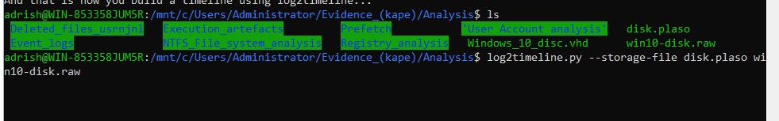
Reading plaso file
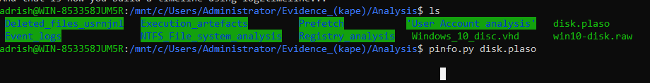
Output file links :-
The files from my target system output can be found here:
- Memory body file: volatility.body
- Disk plaso file: disk.plaso
- Merged Plaso file: timelines-merged.plaso
Plaso file – memory image (.raw initially obtained)
Body file – disk image (.raw file converted from .vhd)
Combining plaso file from memory and body file from disk image.
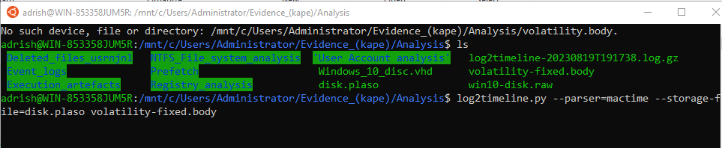
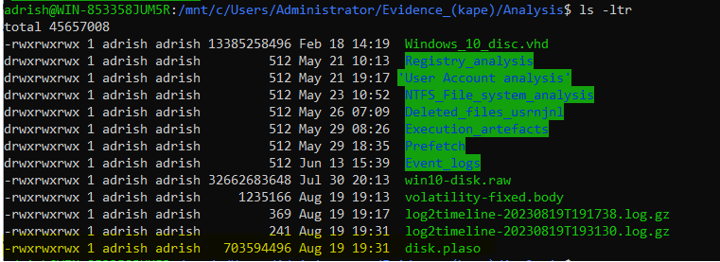
The combined timeline is written into the disk.plaso file.
Converting plaso file to csv for analysing the timeline in EZ timeline explorer.
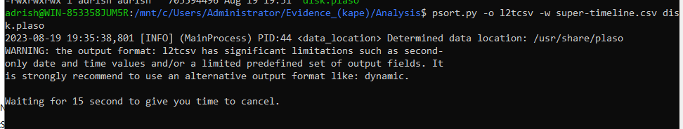
In the super-timeline.csv file we can see dll list loaded for a certain process (i.e. Notepad.exe).
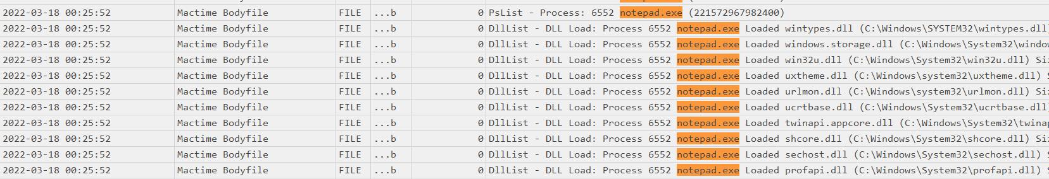
This information is obtained from he body file.
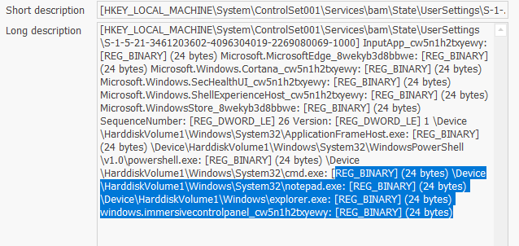
BAM (Background Activity Monitor) records process’s that were running at the time of system shutdown.
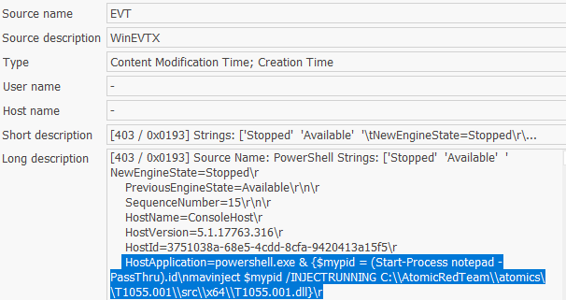
In the above SS we can see the mavinject inserting the malicious DLL into notepad process.

